American Heart Association  2018 ST. LOUIS HEART BALL  AUCTION DONOR  AGREEMENT FORM |  | Please return by Dec. 15, 2017, to:  Dana Benedicktus  American Heart Association  460 N. Lindbergh Blvd.  St. Louis, MO 63141  Fax 314-692-5694 dana.benedicktus@heart.org
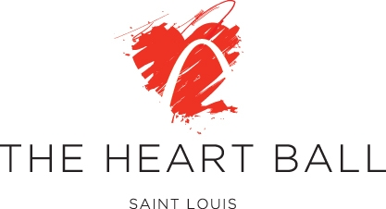
Yes, I would like to donate an item/service to the St. Louis Heart Ball auction on February 24, 2018.
Download this form at www.heart.org/stlheartball
Donor Information |  |  |  | For multiple donors, please include all names you would like listed with item.
Donor name(s) for listing
Contact Person |  |  |  |  |  |  |  |  |  |  |  |  |  | ☐ I wish to remain anonymous. Please do not list my business or name with item.
Address
City, State, Zip
Phone |  |  |  |  |  |  |  |  |  | E-mail
Item Information
Item(s) or Service: |  |  |  |  |  | AHA reserves the right to package donated items with other donated items.
Detailed Item/Service Description: |  |  |  |  |  | Information will appear with item as written here.
Restrictions/expirations of item/service: |  |  |  |  |  |  |  | Please date gift certificates February 24, 2018, and allow a minimum of  six months to redeem; one year preferred.
Donor’s estimated value of item: |  |  |  |  |  |  | $ |  |  |  |  |  | The IRS requires AHA to provide this amount to the buyer.
If donation is a gift certificate: |  |  |  |  |  |  | ☐ Gift certificate enclosed ☐ AHA to prepare gift certificate
Delivery Information |  |  |  |  | Item(s) need to be received no later than January 20, 2018.
☐ Please have volunteer pick up item
☐ Donor to deliver item |  |  |  |  |  |  |  |  |  |  | Does item have display material? ☐ Yes ☐ No
☐ Item accompanies donation form |  |  |  |  |  |  |  |  |  |  | If yes, will the material need to be returned? ☐ Yes ☐ No
I/we agree to donate the item or service named herein for the American Heart Association’s Heart Ball scheduled for February 24, 2018, at the Chase Park Plaza Hotel in St Louis.
Donor Signature |  |  |  |  |  |  |  |  |  |  |  |  |  |  |  | Date
No goods or services were provided to donors in consideration of this gift.
Thank You for Your Support!
TO BE COMPLETED BY AMERICAN HEART ASSOCIATION STAFF/VOLUNTEERS ☐ Recorded GG
☐ Item Received | Date |  | By
☐ Acknowledgement Sent | Date |  | By

